**ZONIFY – A Scalable & Dynamic E-Commerce Platform**

A fully dynamic, performance-optimized, and user-friendly e-commerce platform, built with modern web technologies to deliver a seamless shopping experience.

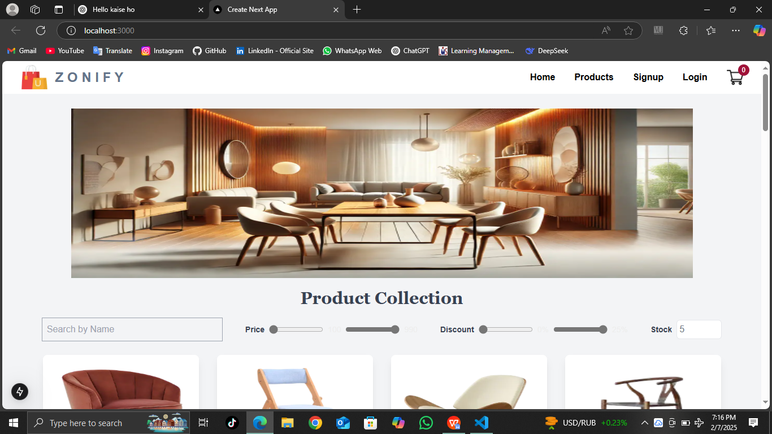

**1. Dynamic Product Listing with Sanity**

ZONIFY’s product listing is powered by Sanity CMS, ensuring real-time updates and efficient content management.

The product list dynamically displays:  
✅ Product Title  
✅ Price  
✅ Stock Level  
✅ Discount Percentage

Note: Product descriptions were intentionally excluded to maintain a clean UI and optimal user experience.

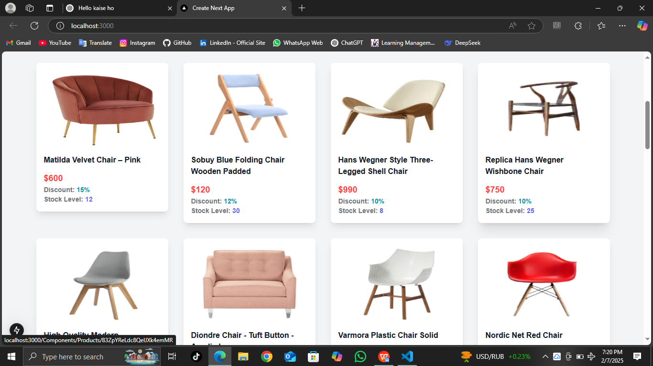

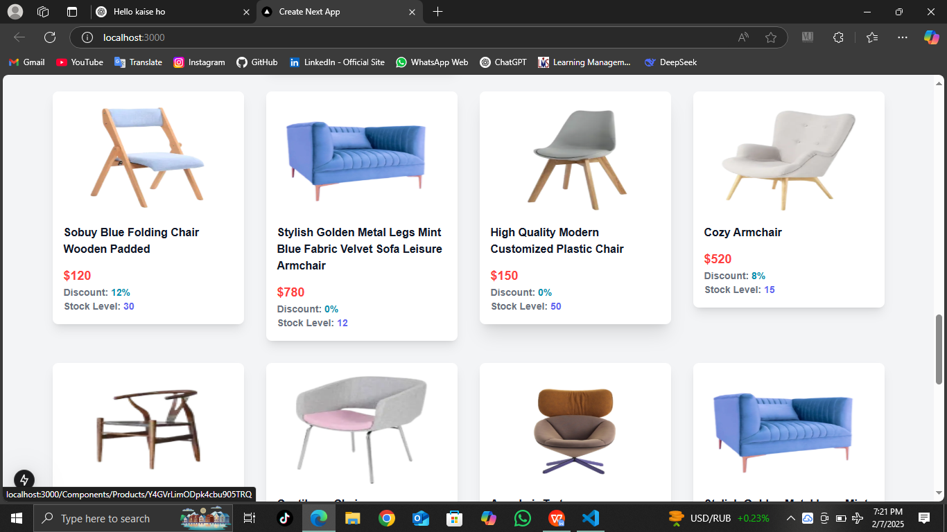

2. Detailed Product Page with Dynamic Routing

Each product has a dedicated product details page, implemented using dynamic routing for smooth navigation.

The product details page includes:  
✅ Product Title  
⭐ Rating (Star System)  
✅ Price  
✅ Discount Percentage  
✅ Short Description  
✅ Category  
✅ Stock Level  
➕ **"Add to Cart" Button**

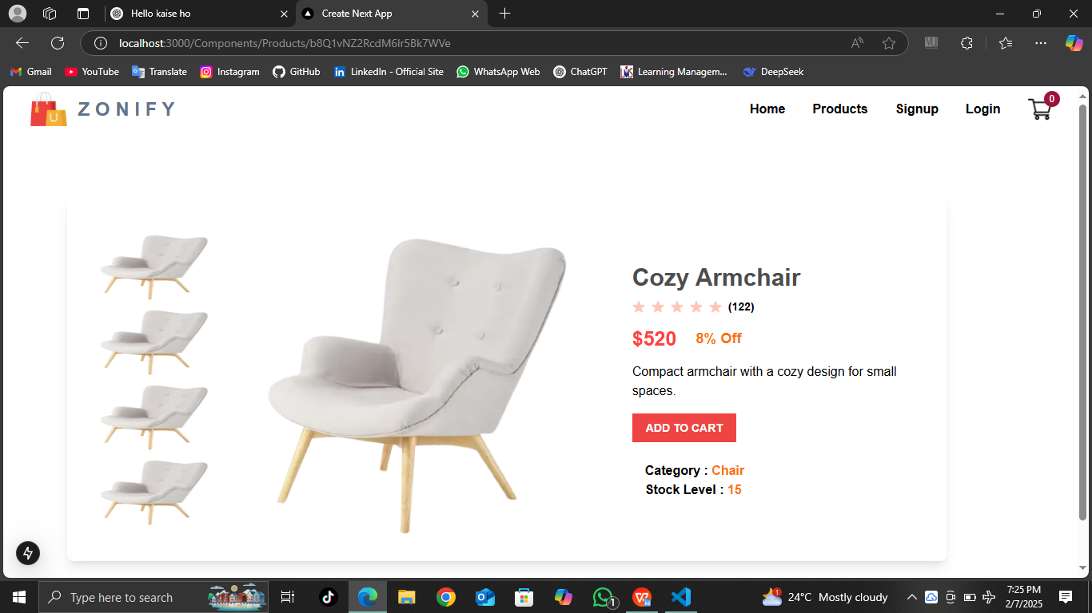

1. Smart Add-to-Cart Functionality

ZONIFY offers a one-click Add-to-Cart system, ensuring an effortless shopping experience.

Features:  
  
✅ Instant cart updates when a product is added.  
✅ Real-time item count updates on the navbar cart icon (e.g., 1 → 2 → 3, etc.).  
✅ Automatic quantity adjustments when adding duplicate items.

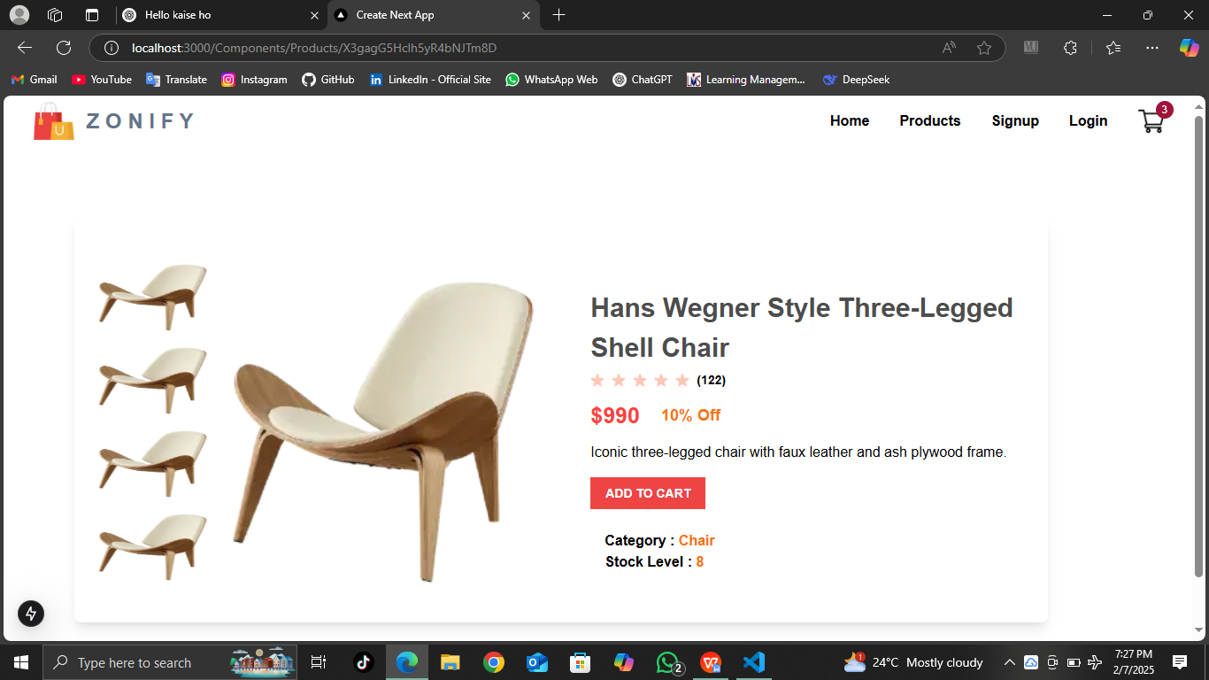

1. Shopping Cart Component – A Seamless Experience

The ZONIFY Cart Component provides a structured and user-friendly shopping cart interface.

Key Features:  
✅ Product Breakdown:

✅ Product Title

✅ Unit Price

✅ Quantity Selector (with increment/decrement options)

✅ Total Price per Product

✅ Remove Item Button ❌

✅ Price Calculation:

✅ Subtotal (Total before any additional charges)

✅ Grand Total (Final cart amount after calculations)

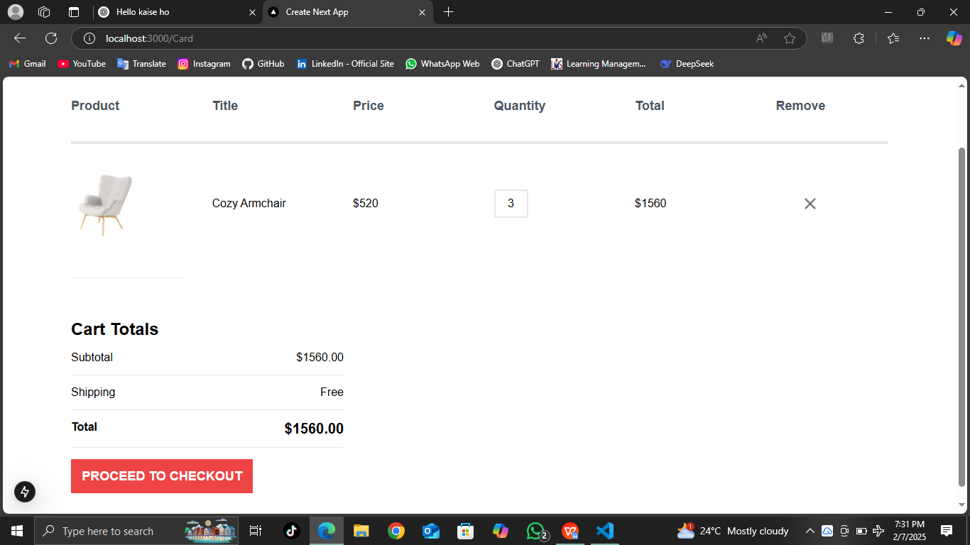

5. Advanced Filtering System for Enhanced User Experience

ZONIFY ensures smooth product discovery with multiple filtering options:  
  
✅ Search by Product Name – Find specific products instantly.

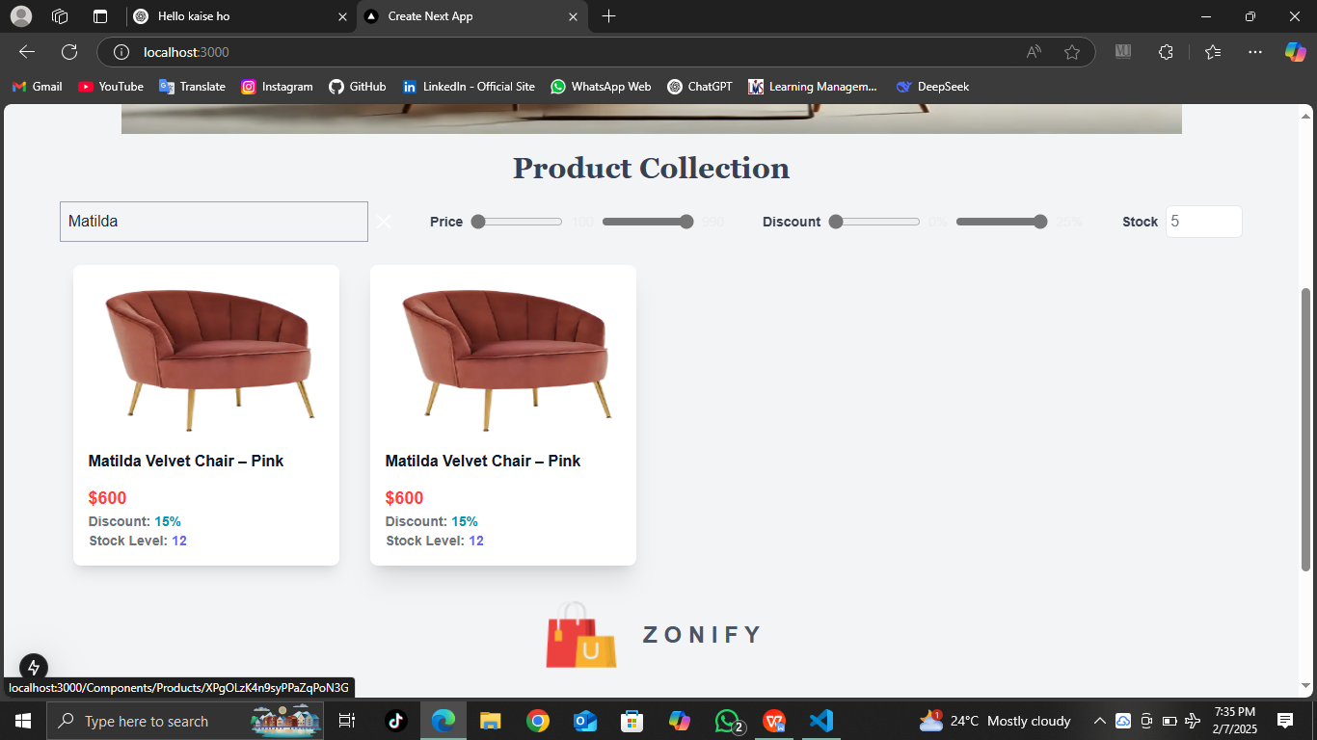

✅ Filter by Price Range – Adjust the budget and view products accordingly.

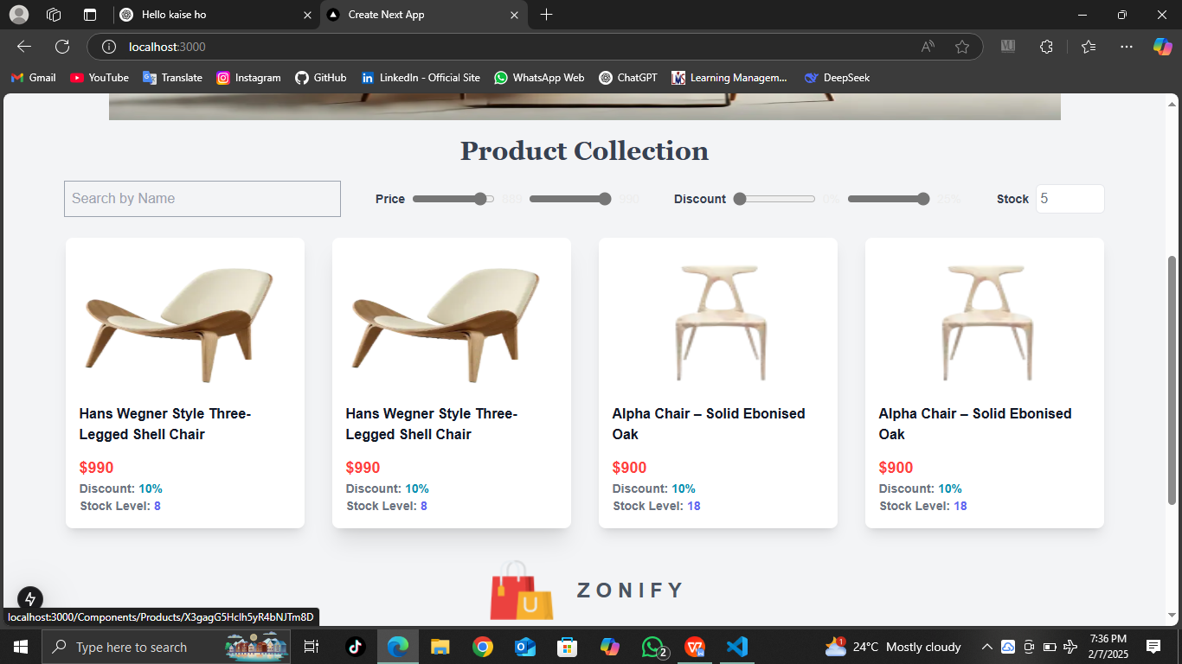

✅ Filter by Discount Percentage – Identify the best deals.

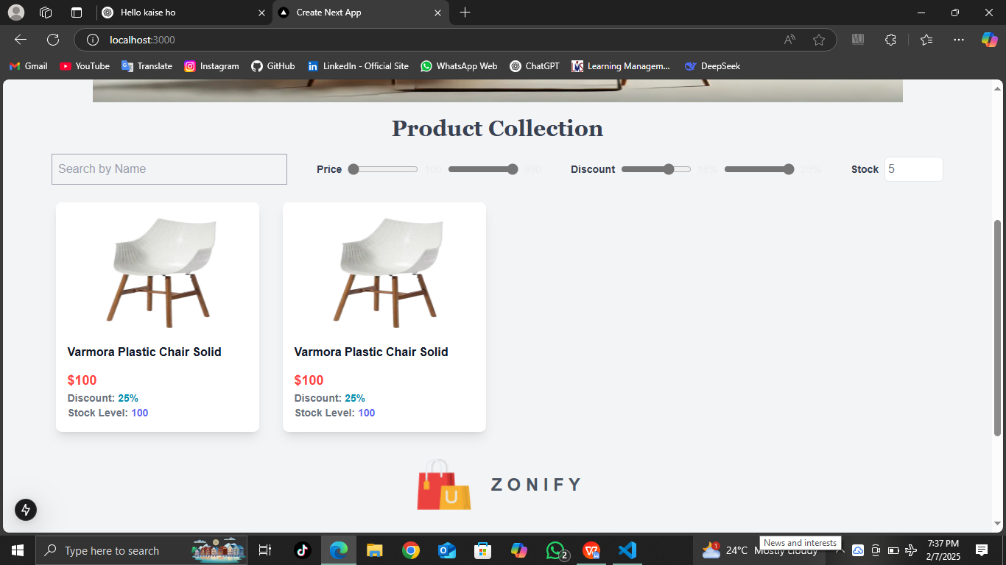

✅ Filter by Stock Level – Display only available products.

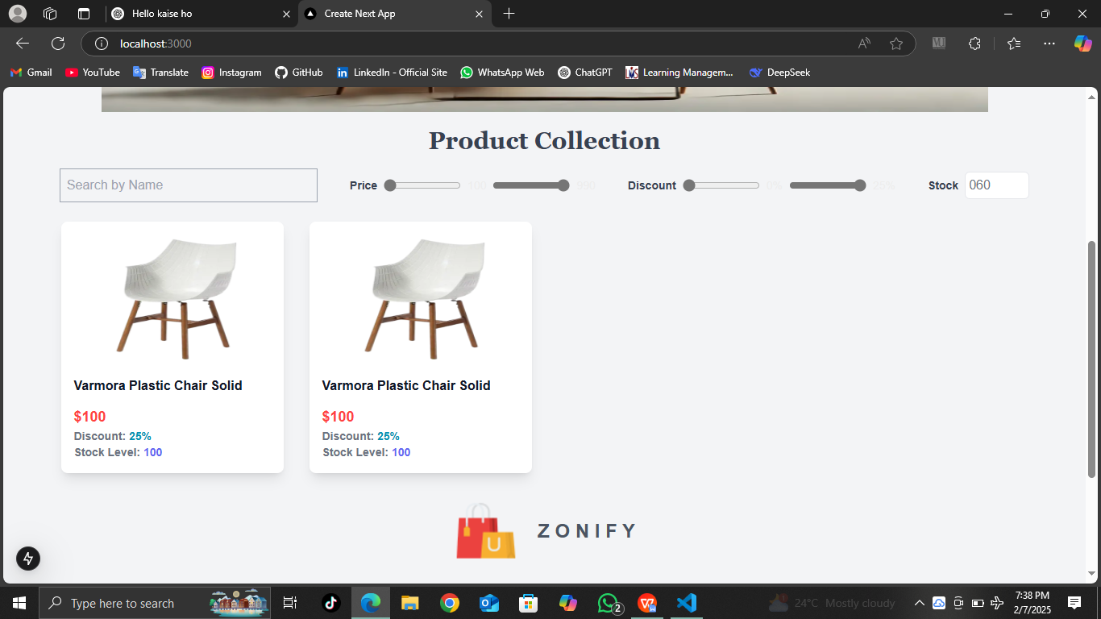

6. Live Cart Icon with Item Count Updates

The Navbar Cart Icon dynamically updates when items are added or removed:  
  
✅ Real-time count updates (1 → 2 → 3, etc.).  
✅ Automatically decreases when items are removed.

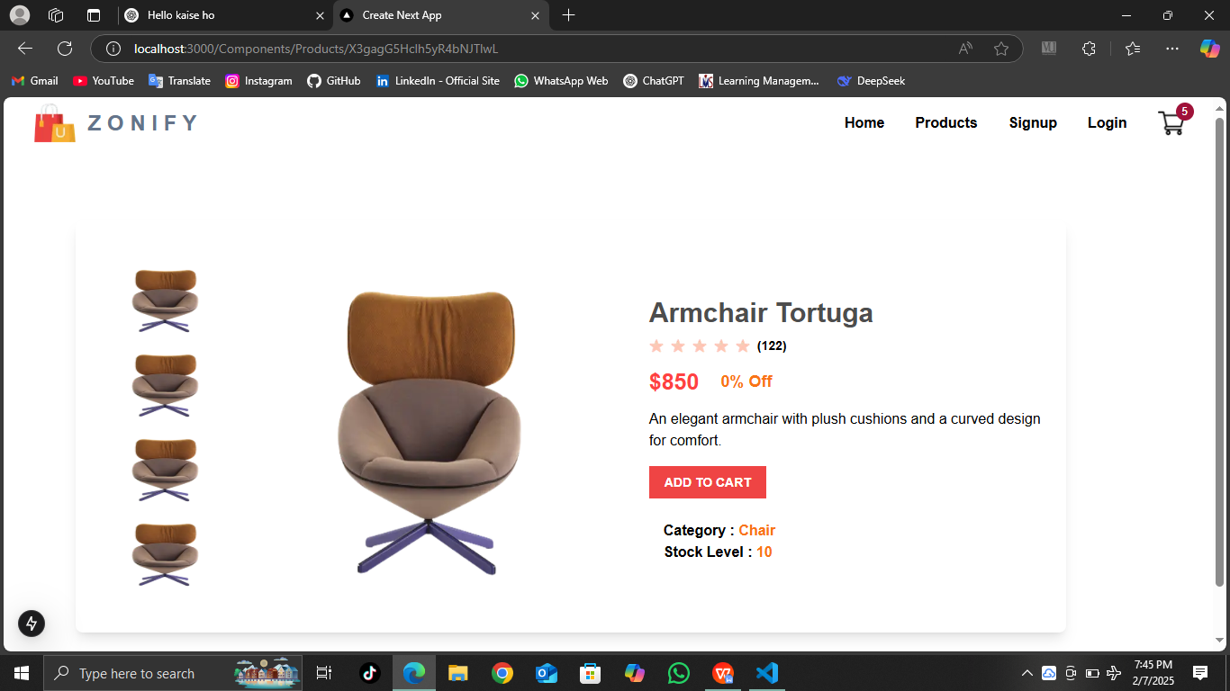

Conclusion: A Scalable & Optimized Shopping Experience

ZONIFY provides an efficient, user-friendly, and scalable e-commerce solution with:

✅ Real-time product updates  
✅ Seamless cart management  
✅ Advanced search and filtering options

✅ ZONIFY – The Ultimate Shopping Experience, Designed for Speed, Efficiency, and Scalability!